BEHAVIOR CHANGE CONTRACT
Health Behavior Change Plan

Identify ONE target behavior you would like to change. Summarize the behavior to be changed. What changes can you make now? In the near future?

I want to become more confident and versed in yoga. The few times I have done yoga, I left the session feeling relaxed and refreshed and I think consistently practicing yoga would help me manage my stress and anxiety.

My behavior change will be: I am looking to practice yoga more frequently and fluidly.

My long-term goal for this behavior is: Be able to do a headstand.

There are 3 obstacles to change (things that I am currently doing or situations that contribute to this behavior or change):
1. I am not flexible at all and have not really practiced yoga so it is completely new to me.
2. I would like to be practicing yoga in the morning but I snooze my alarms a lot.
3. I do not have access to a yoga studio/cannot afford yoga classes right now.

The strategies I will use to overcome these obstacles are:
1. The purpose of practicing is to get better so it is okay that I do not know a lot about yoga.
2. I will set my alarm 15 minutes earlier than needed to give me time to wake up. I will take off the ‘snooze’ option on my alarms so it forces me to wake up.
3. I will use Youtube and the internet to find at home yoga sessions. I do not have a roommate so I can practice yoga in my room.

There are three motivating forces for changing this behavior:
1. Stretching and becoming more flexible – helps my muscles for when I work out.
2. Meditating and becoming more mindful will help ease anxiety and will allow my brain to focus on the moment.
3. I really want to be into yoga and know what I’m talking about.
List groups or organizations that may help you change your behavior. Consider resources on campus (friends, Student Wellness Center, clubs, societies, etc.) and community-based resources (support groups, non-profit organizations), books/reputable website resources, etc.:
- Youtube has a lot of programs and videos for beginners that I can follow. The local YMCA may have yoga classes I could participate in every once in a while to get community and instructor support.

1. Set realistic, specific goals and rewards for goal achievement. Some examples of Behavior Goals:
I want to sleep……… ….. 8 hours per night.
I want to exercise…… .… 3 times a week for 45 minutes.
I want to relax……………by doing breathing exercises 4 times per day.

(Break your goal into two or more “mini-goals” (e.g., Improve my physical fitness by exercising at least three days a week for 30 minutes. Improve my emotional control by doing breathing exercises at least four times a day.)

Goal #1: I want to complete 2 days of yoga each week.
Target Date #1: October 21st
Reward: Buy a new yoga mat

Goal #2: Correctly do a forward bend and hold my ankles
Target Date #2: November 11th
Reward: Buy a new outfit

Final Goal: Do a headstand
Final Goal Date: December 9th
Reward: Have a spa day

Assessment: ASSESS HOW WELL YOU ACCOMPLISHED YOUR GOAL

Goal Attainment Scale: Using a Goal Attainment Scale is a way to measure the progress you are making toward achieving your goal. We recommend a 4-point scale. On this scale, Level 4 represents a significant level of improvement in the behavior you are trying to change. Level 3 represents an improvement in the behavior, and Level 2 represents your present level. Finally, Level 1 represents a decline in the behavior you are trying to change; that is, your behavior change is going in the opposite direction of your goal. Below is an example for the behavior of “walking”:

Level 4 = significant improvement Walked for at least 30 minutes six days a week
Level 3 = noticeable improvement Walked 30 minutes every other day
Level 2 = present behavior Walked 2 times a week for one month
Level 1 = noticeable decline Walked 20 minutes once every ten days

On the lines below, write a description of the behavior that will serve as the standard for each level of your Goal Attainment Scale:

Level 4: Completed 3 full yoga sessions in a week (at least 30 minutes)

Level 3: Completed 1 hour of yoga a week

Level 2: Stretch for a few minutes a day

Level 1: Stretch once a week

Devise and state a strategy or plan of action and a method for tracking (e.g., chart, graph, app) you will use to monitor your progress. Below is an example of what this may look like:

Date | Goal Activity | Goal Attainment Score | Driving Forces | Restraining Forces | Possible Actions to overcome Restraining Forces and/or enhance Driving Forces
2/13 | Walked for 30 minutes once this week. | 1 | Friend called me once to walk. | Watched TV. Played video games. | Ask friend to call me every time he exercises. Reward myself with 30 minutes of video game playing after walking for 30 minutes.

I will be using an app called Tally to track and record my progress. It has an alert for each day at the time I plan on doing my yoga sessions. Screenshots of the app and how I will be using them will be at the end of this document.

Consider what supplies you will need, how you will modify your environment, the people who will be your support system and how you will handle challenging situations.

I have an old yoga mat that I can use to start doing yoga on. I do not have a roommate but I am in a double room so I have plenty of room. I can lay out my yoga mat where I intend to do it and make the space inviting and ready the night before. I will tell my friends and my mom about my specific goals so they know what my intentions are. This will help keep me accountable and on track to reach my goals. I will need my laptop and internet to find yoga sessions on Youtube.
Incentives: Reward yourself appropriately for your accomplishments along the way to your goal. At the beginning of your program, if appropriate, reward yourself after every successful action. Then, when the target behavior becomes better established, reward yourself less frequently. Have in mind rewards that you could give yourself after completing your short-term goal activities, as well as your long-term behavior change. Rewards can be anything from savoring feelings of satisfaction, to spending time with friends, to a new music CD, etc.

I will reward myself at each goal with a big item. I will also reward myself each week I think I made successful improvements towards my goal with

Making Adjustments: Review your Tracking Chart (or other method) after you are into your program for two weeks. Are you being successful? Do you need to reconsider the barriers and motivators, and the action steps? Is it necessary for you to restate your goal statement for your target behavior? Making adjustments is part of the process. Keep in mind, that persistence is very important to successful behavior change. Chart your progress in a journal and at the end of ONE MONTH; describe how successful you were in following your behavior change plan. If you weren’t as successful as you’d like, what barriers might have influenced this? Be specific. (Note: Students do need to submit actual journals with Health Behavior Change project.)

Make a Commitment by Signing a Personal Behavior Change Contract:

I, Sophie Harper agree to practicing yoga in the mornings.

I will begin Wednesday, October 3rd, 2018, and plan to reach my goal of doing a headstand,
By December, 9th, 2018.

By signing this contract, I have made a commitment to changing my behavior and I have had Priscilla Hernandez witness my contract.

Your signature: Sophie Harper Date: 10/01/18
Witness signature: Priscilla Hernandez Date: 10/01/18


This is the main page. This is where I can monitor how many successful days I have had for my behavior change.

Adapted from Monroe College’s HED-130 Foundations of Health and Wellness course, & Kansas State University 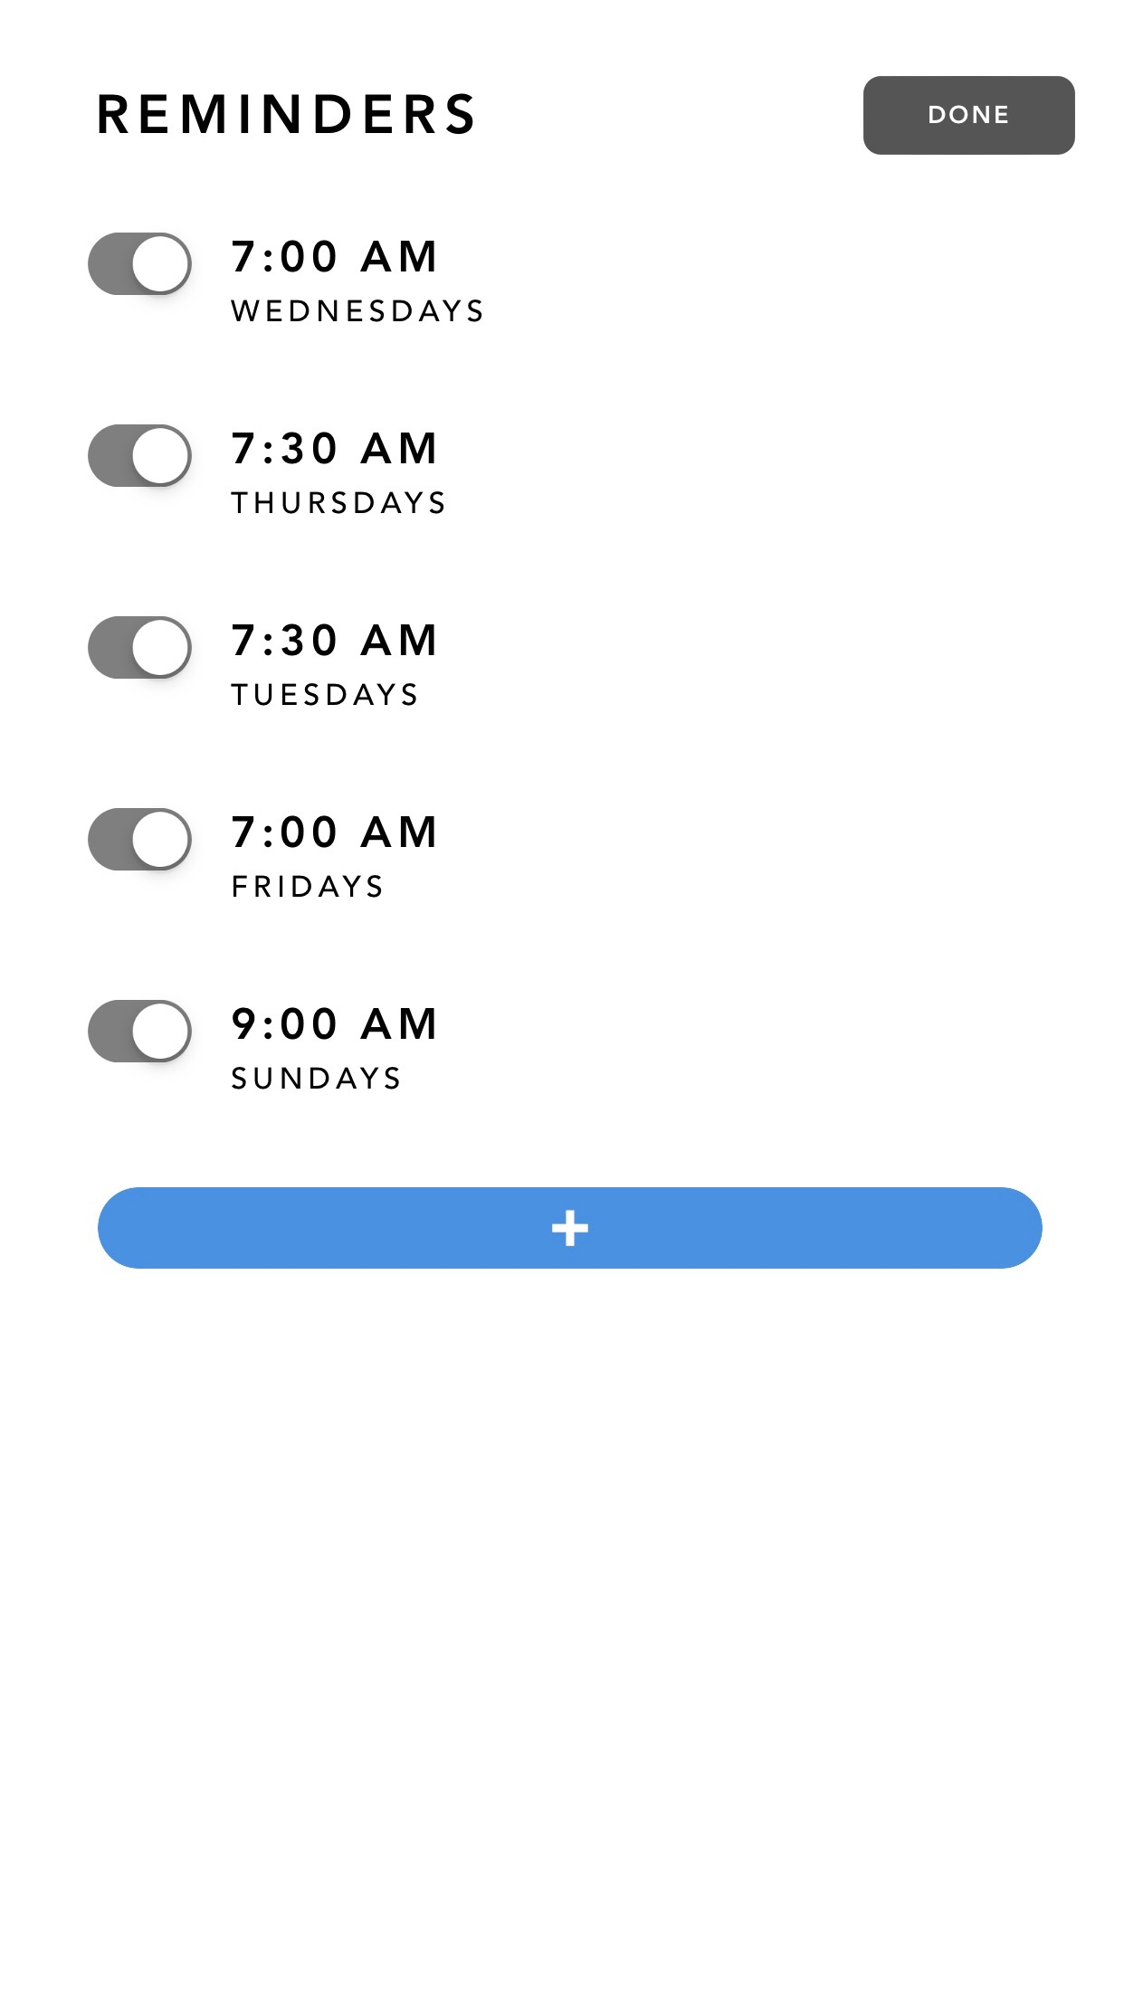 This is where my reminders are. I have 5 reminders in the week right when I wake up to complete my yoga.  This is where I can journal about the behavior for that specific entry. I can talk about the motivation, determination, etc. 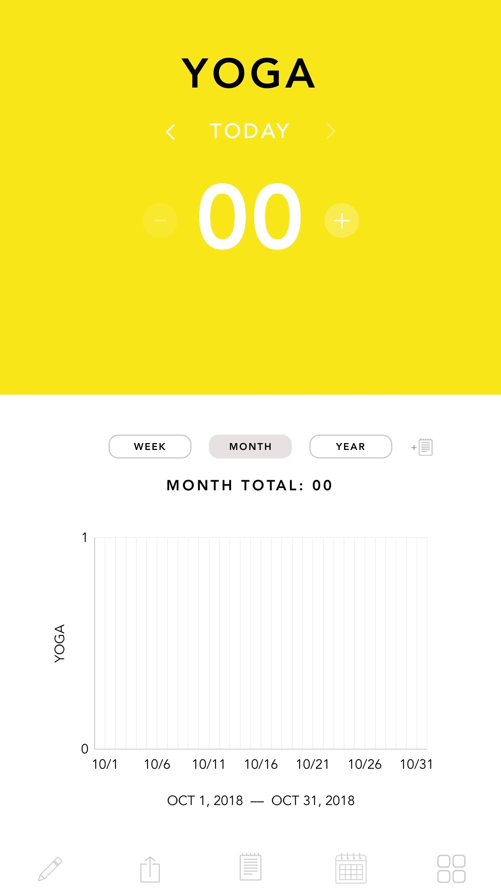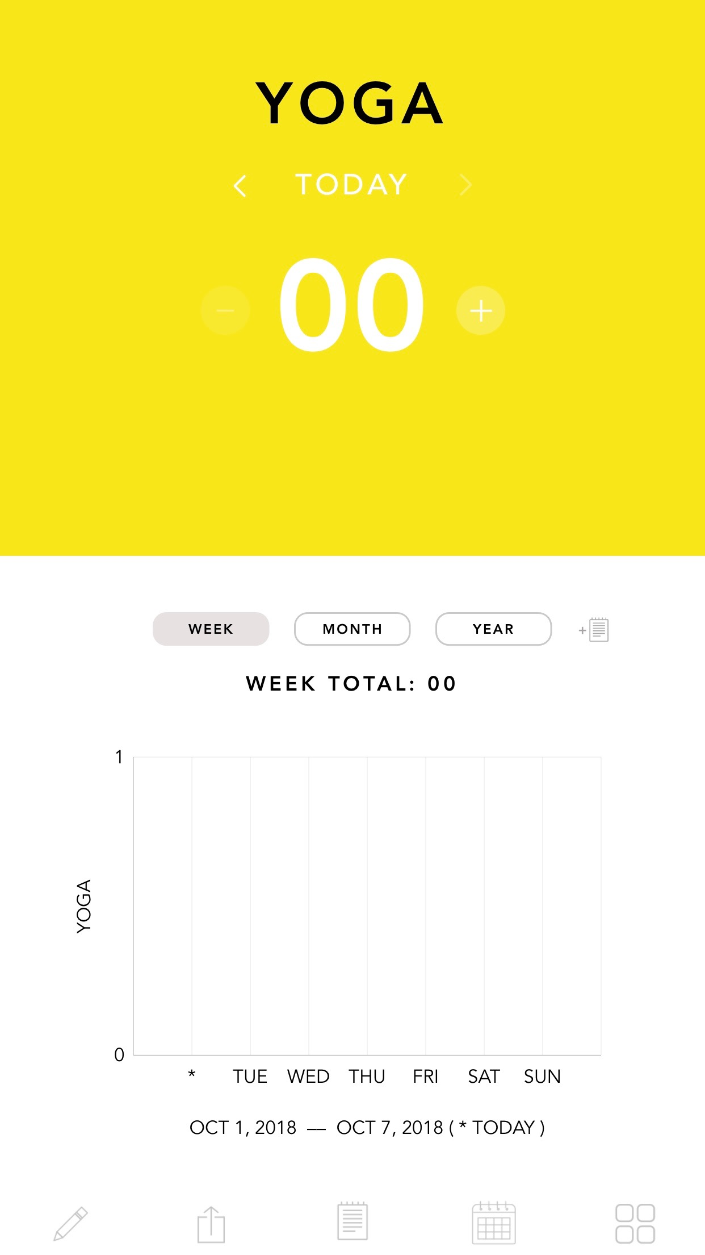 This is where my monthly and weekly progress reports will be. I will visually see if I am improving or maintaining or declining. Website URL: http://sophieharper.whittier.domains/

